LAB NO 2

**Q1:-The following SELECT statement executes successfully:**

**SELECT last_name, job_id, salary AS Sal FROM employees;**

**A:** Select last_name, job_id,salary AS Sal FROM HR.employees;

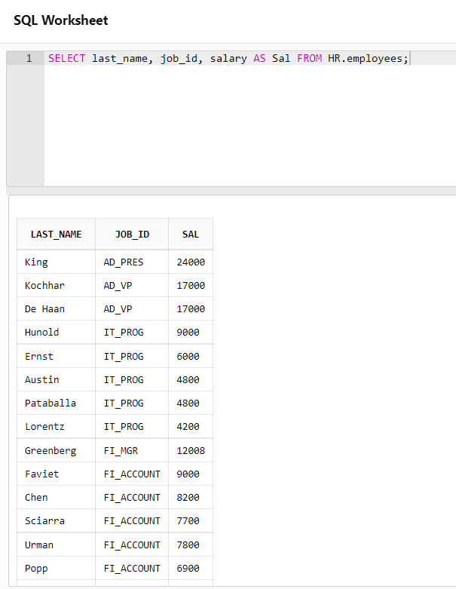

**Q2:-Show the structure of the DEPARTMENTS table. Select all data from the DEPARTMENTS table**

**A:** select * from HR.”DEPARTMENTS”;

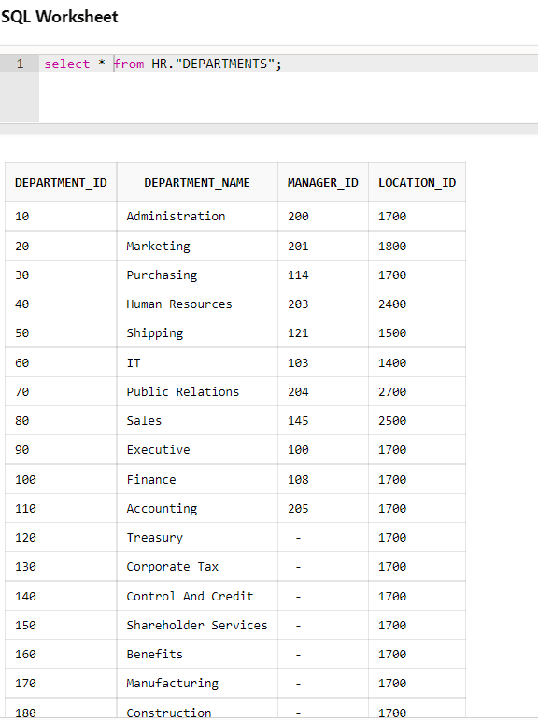

**Q3:-Show the structure of the EMPLOYEES table. Create a query to display the last name, job**

**code, hire date, and employee number for each employee, with employee number appearing first.**

**A:** select employee_id,last_name,job_id,hire_date from HR.”EMPLOYEES”;

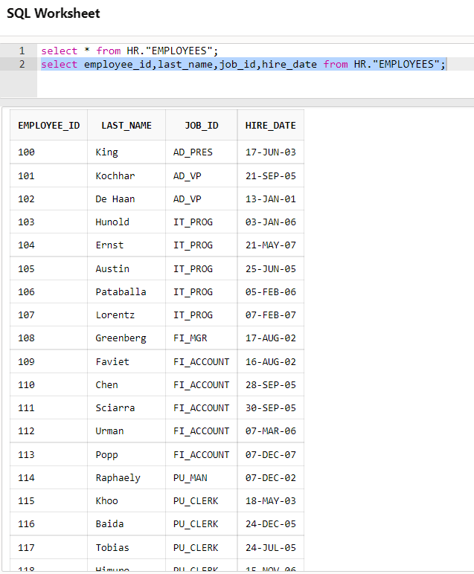

**Q4:-Create a query to display unique job codes from the EMPLOYEES table. Display the last name**

**concatenated with the job ID, separated by a comma and space, and name the column Employee**

**and Title.**

**A:** select distinct job_id from HR.”EMPLOYEES”;

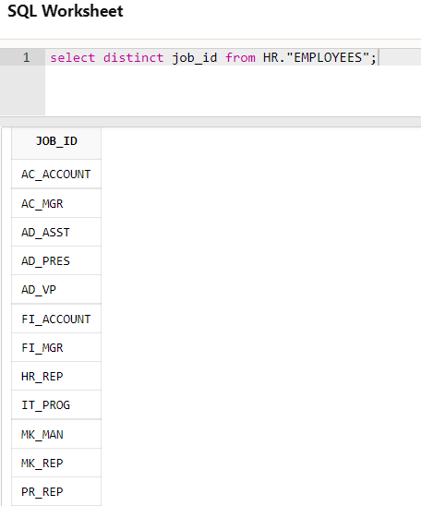

select last_name || ‘ ‘ || job_id as ”Employee and Title” from HR.”EMPLOYEES”;

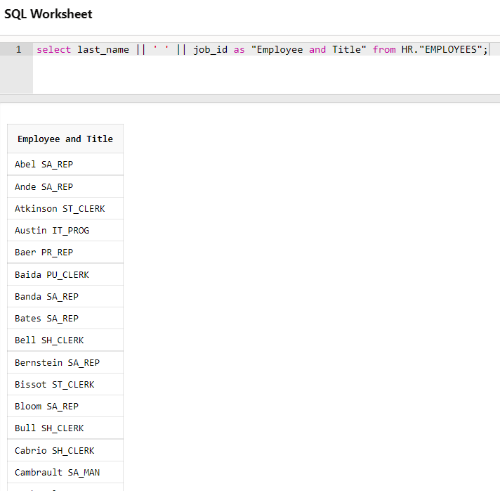

**Q5:-Create a query to display all the data from the EMPLOYEES table. Separate each column by a**

**comma. Name the column THE_OUTPUT.**

**A:** select EMPLOYEE_ID ||','|| FIRST_NAME ||','|| LAST_NAME ||','||

EMAIL ||','||PHONE_NUMBER||','||HIRE_DATE||','||JOB_ID||','|| SALARY||','||

COMMISSION_PCT||','|| MANAGER_ID||','||DEPARTMENT_ID as "The Output"

from HR."EMPLOYEES";

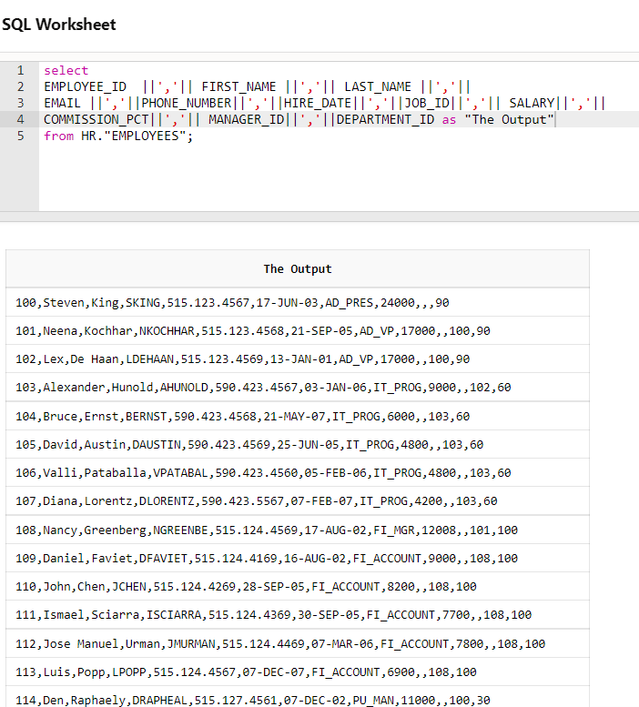

**Q6:-Create a query to display unique job codes from the EMPLOYEES table.**

**A:** select distinct job_id from HR.”EMPLOYEES”;

